ASPECT 4: Place Value Assessment

Student: ________________ Class: _____________ Assessment 1 Date: _____ Level:______

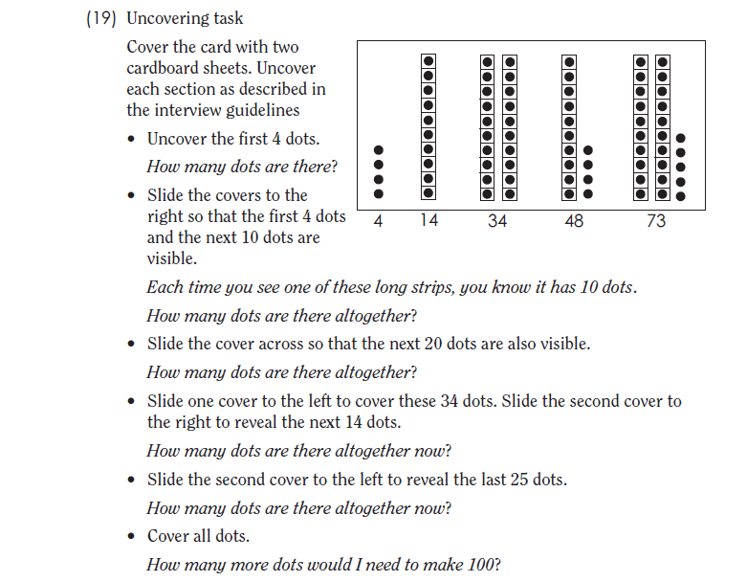 Assessment 2 Date: _____ Level: ______

Teacher Notes

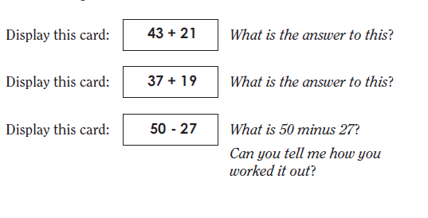

Teacher Notes

Teacher Notes

**121+117**

Display this card:*What is the answer to this*?

Display this card:*What is the answer to this*?

**437+348**

**332-116**

Display this card: *What is 332 minus 116*?

*Can you tell me how you worked it out*?

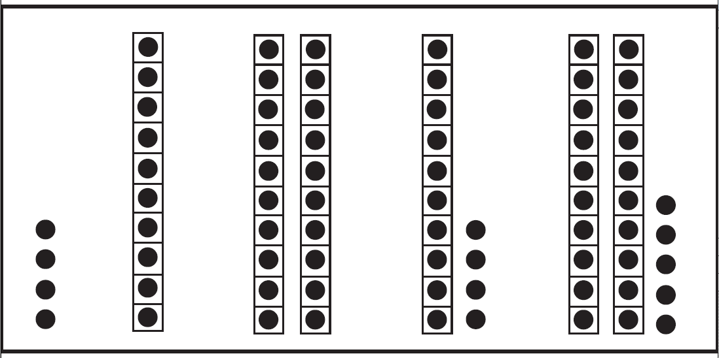

|  |  |
| --- | --- |
| 43 + 21 | 121 + 117 |
| 37 + 19 | 437 + 348 |
| 50 - 27 | 332 - 116 |

How to find out where they are up to on Aspect 4: Place Value?

|  |  |  |  |  |  |
| --- | --- | --- | --- | --- | --- |
| **PV level 0**  **MA1-4NA MA1-5NS**  Counts on but uses single units of one or 10 in counting strategies. Knows the sequence of multiples of ten, 10,20,30,… as sequenced count.  Treats ten as something constructed of *ten 1’s,*  but one *ten* and ten *ones* do not exist for the student at the same time. | **PV level 1**  **MA1-4NA MA1-5NA**  Counts by tens and ones from the middle of the decade to find the total or difference of two 2-digit numbers where one of the numbers is represented by materials.  Treats ten as a single unit while still recogising that it contains ten *ones* (abstract composite unit).    Adds or subtracts two, two-digit numbers with one number represented by material. | **PV level 2**  **MA2-4NA MA2-5NA**  2a: *Jump Method*  Treats ten as a unit that can be repeatedly constructed in place of ten individual counts. Tens and ones are flexibly regrouped. Counts forwards and backwards firstly by tens and then by ones.  *2b: Split Method*  Treats ten as a unit as an abstract composite unit. Solves addition and subtraction problems mentally by separating the tens from the ones, then adding or subtracting each separately before combining. Uses non-standard decomposition of two-digit numbers. E.g. 76= 60+16. | **PV Level 3**  **MA2-4NA MA2-5NA**  3a: *Jump Method*  Uses hundreds, tens and ones in standard decomposition, e.g. 326 as three groups of 100, two groups of 10 & six 1s. Increments by hundreds and tens to add mentally. Determines the number of tens in 621 without counting by ten.  3b: *Split Method*  Adds and subtracts mentally combinations of numbers to 1 000. Uses the positional value of numbers to flexibly in regrouping without a need to rely on incrementing by tens or hundreds. Uses a part-whole knowledge of numbers to 1 000. | **PV Level 4**  **MA3-7NA**  Uses tenths and hundredths to represent fractional parts with an understanding of the positional value of decimals. For example 0.8 is larger than 0.75 because of the positional value of the digits.  Interchanges tenths and hundredths, e.g. 0.75 may be thought of as seven tenths and five hundredths. | **PV Level 5**  **MA3-5NA MA3-6NA**  Recognises that the place value system can be extended indefinitely in two directions- to the left and right of the decimal point.  Recognises the relationship between values of adjacent places (units) in a numeral |

Students need to be at least at the Counting-on-and-back stage to be placed on the Place Value aspect.

|  |  |  |
| --- | --- | --- |
| **PV level 0 MA1-4NA MA1-5NS**  See EAS Counts-on-and-back.   1. See Counting by 10s and 100s, Aspect 1D Level 1     Uncover the first 4 dots. *How many dots are there*?  Slide the covers to the right so that the first 4 dots and the next 10 dots are visible.  *Each time you see one of these long strips, you*  *know it has 10 dots*. *How many dots are there altogether*?  Stop if the student counts on by ones. (The student would be determined to be at level 0). | • **PV level 1 MA1-4NA MA1-5NA**    Cover the card with two cardboard sheets.  Slide the cover across so that the next 20 dots are also visible.  *How many dots are there altogether*?  Slide one cover to the left to cover these 34 dots. Slide the second cover to the right to reveal the next 14 dots.  *How many dots are there altogether now*?  Slide the second cover to the left to reveal the last 25 dots.  *How many dots are there altogether now*?  Students are determined to be at Level 1 (Ten as a unit) if they successfully manipulate tens and ones in this task.  • Ask the student to explain the strategy used.  • Success with these tasks may indicate Level 2 (Tens & ones).  • Identify if the student used a split or jump method to solve the tasks. | **PV level 2 MA2-4NA MA2-5NA**  Cover all dots.  *How many more dots would I need to make 100*?  If students successfully answer the final question above, they would be at Level 2 because all the dots are covered.  SEE EAS Facile  Display this card: **43 + 21** *What is the answer to this*?  Display this card: **37 + 19** *What is the answer to this*?  Display this card: **50 – 27** *What is 50 minus 27*?  *Can you tell me how you worked it out*?  Ask the student to explain the strategy used.  • Identify if the student used a split or jump method to solve the tasks. |
| **PV Level 3**  **MA2-4NA MA2-5NA**  3a: *Jump Method*  Uses hundreds, tens and ones in standard decomposition, e.g. 326 as three groups of 100, two groups of 10 & six 1s.  Increments by hundreds and tens to add mentally.  Determines the number of tens in 621 without counting by ten.  3b: *Split Method*  Adds and subtracts mentally combinations of numbers to 1 000.  Uses the positional value of numbers to flexibly in regrouping without a need to rely on incrementing by tens or hundreds.  Uses a part-whole knowledge of numbers to 1 000. Display this card: **121+117***What is the answer to this*?  Display this card: **437+348** *What is the answer to this*?  Display this card: **332-116** *What is 332 minus 116*?  *Can you tell me how you worked it out*?  Ask the student to explain the strategy used.  • Identify if the student used a split or jump method to solve the tasks mentally. | **PV Level 4**  **MA3-7NA**  Uses tenths and hundredths to represent fractional parts with an understanding of the positional value of decimals. For example 0.8 is larger than 0.75 because of the positional value of the digits.  Interchanges tenths and hundredths, e.g. 0.75 may be thought of as seven tenths and five hundredths. | **PV Level 5**  **MA3-5NA MA3-6NA**  Recognises that the place value system can be extended indefinitely in two directions- to the left and right of the decimal point.  Recognises the relationship between values of adjacent places (units) in a numeral |