List of Rowland Hassall Wellbeing Apps
Subject | App name | Price | Description | Age/level
Wellbeing | Autism Apps  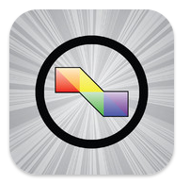 | Free | A comprehensive list of apps that are being used with and by people diagnosed with autism, Down syndrome and other special needs. It also includes links to any available information that can be found for each app. The Apps are also separated into over 30 categories, and the descriptions are all searchable, so any type of app is easy to find and download.
 | Let Panic Go  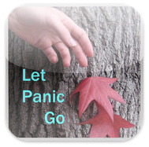 | $2.99 | Designed to interrupt the cycle of thoughts and body sensations that fuel a panic attack. Features  - Biofeedback enhanced, to help regain control over breathing  - No audio necessary-- visually formatted for rapid access and ease of use  - Incorporates mindfulness and cognitive behavioral techniques  - Simple instructions with built-in training module  - Guided exercise adapts to user's level of relief  Together these methods make room for the fear to pass, all on its own.
 | iCounselor: Angry  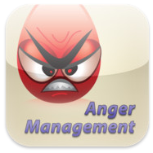 | $0.99 | You first rate your level of anger on a color coded scale of 0 (not angry at all/content) to 10 (enraged).  You then move on to the first set of skills, where you select one of ten different calming activities to perform. If you are not sure which skill to select, shake the iPhone or iPod and one will be randomly chosen.  After following the instructions for the calming activity, you select one of ten ways to change your thoughts (or again, you may shake the device for a random selection). Changing your thoughts in order to change your feelings is the basis of cognitive behavioral psychotherapy, the most widely practiced evidence based form of psychotherapy.  After utilizing one of the thought changers, you proceed to selecting one type of solution for the problem that triggered your anger, or shake the device for a random selection.  After implementing your solution, you rate your level of anger again in order to determine if the skills you chose were effective for you. If your level of anger has not reduced sufficiently, you will be given the opportunity to try again, selecting a different skill set.
Wellbeing | iCounselor: Anxiety  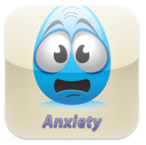 | $0.99 | You first rate your level of anxiety on a color coded scale of 0 (at ease) to 10 (panicked).  You then move on to the first set of skills, where you will select one of ten different calming activities to perform. If you are not sure which skill to select, shake the iPhone or iPod and one will be randomly chosen.  After following the instructions for the calming activity, you will select one of ten ways to change your thoughts (or again, you may shake the device for a random selection). Changing your thoughts in order to change your feelings is the basis of cognitive behavioral psychotherapy, the most widely practiced evidence based form of psychotherapy.  After utilizing one of the thought changers, you proceed to selecting one type of solution for the problem that triggered your anxiety, or shake the device for a random selection.  After implementing your solution, you rate your level of anxiety again in order to determine if the skills you chose were effective for you. If your level of anxiety has not reduced sufficiently, you will be given the opportunity to try again, selecting a different skill set.
 | iCounselor: Depression  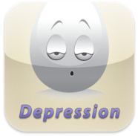 | $0.99 | You first rate the intensity of your depressive symptoms on a color coded scale from 0 (happy) to 10 (extremely depressed).  You move on to the first set of skills, where you will select one of ten ways to change your thoughts. If you are not sure which skill to select, shake the iPhone or iPod and one will be randomly chosen. Changing your thoughts to change your feelings is the basis of cognitive behavioral psychotherapy, the most widely practiced and evidence based form of psychotherapy.  After utilizing one of the thought changers, you proceed to selecting one method for making lifestyle changes that will reduce depression (or again, you may shake the device for a random selection).  After following the instructions for the lifestyle changes, you then move on to the third set of skills, where you will select one of ten different relaxation strategies for managing stress, or shake the device for a random selection.  After implementing those skills, you rate the level of depression again to determine if the skills you chose were effective for you. If the level of the depression has not reduced sufficiently, you will be given the opportunity to try again, selecting a different skill set.
Wellbeing | Talking Anxiety  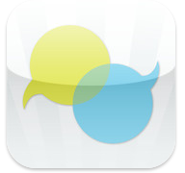 | $2.99 | Learn how to manage anxiety face-to-face from the experts – people who've 'been there' and discovered techniques that really work and complement medical therapy.  The app includes video of people explaining the tips that worked for them, 4 sections cover a comprehensive range of topics, quizes to test your own progress, and an optional Daily Tip sent to your iPad or iPhone  Developed with SANE.
 | My Calm Beat  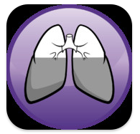 | Free App  BUT  Heart Rate Monitor =  $79.95 | MyCalmBeat is a Brain Exercise by MyBrainSolutions.com that helps improve your ability to manage stress through slow breathing. Slow breathing allows you to increase the variability of your heart rate to decrease stress, improve focus and build resilience.  Using the MyCalmBeat heart rate monitor (available through www.mycalmbeat.com/mycalmbeat), you can calculate your personal best breathing rate where you are likely to be most calm. At this rate, you receive the biggest benefit from your training. You can then train by breathing regularly at your personal best breath rate and tracking your ‘calmness’ over time with the MyCalmBeat heart rate monitor. You can then train on the go with the MyCalmBeat App.  How does it work? Your breathing rate affects your heart rate patterns, which affects how your brain deals with stress. And all these processes are tightly interconnected. While it’s difficult to directly control your heart rate, or your brain function, you can control your breathing rate. By regularly slowing your breathing down, you can improve your heart rate variability, which will allow your brain to more effectively deal with the stressful situations you encounter. Learn more at www.mybrainsolutions.com/mycalmbeat | Boys respond well.
 | Smiling Mind  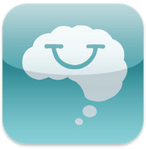 | Free | Smiling Mind is modern meditation for young people. It’s a simple tool that gives a sense of calm, clarity and contentment.  Smiling Mind is a unique web and App-based program developed by a team of psychologists with expertise in youth and adolescent therapy, Mindfulness Meditation and web-based wellness programs. Smiling Mind is a free tool that will assist in improving the lives of young people, and is available online or as a smartphone App.
Health | Quit Now: Quit Smoking  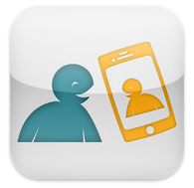 | Free | My QuitBuddy helps you get, and stay, smoke free. It’s with you through the hardest times with helpful tips and distractions to overcome cravings; tracking systems to chart your progress and all the facts you need to understand the impact smoking has on your health.  Better still, My QuitBuddy is easily customised. You can determine whether you’re ready to quit right now or whether you’re intending to do so soon. You can set your own goals, the reasons you’re quitting, include photos and recordings of loved ones and even add buddies you can call upon in times of need.
 | Couch to 5K  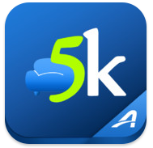 | $1.99 | Get off the couch with the OFFICIAL Couch-to-5K® training app from Active.com! This oft-imitated program has helped thousands of new runners move from the couch to the finish line. Spend just 20 to 30 minutes, three times a week, for nine weeks, and you’ll be ready to finish your first 5K (3.1-mile) race!
Body Image | Body Beautiful | $0.99 | Body Beautiful helps you cultivate a positive self-image and encourage true beauty with inspirational quotes, media articles, videos and tools.  Share your favorite Body Beautiful quotes, articles, and videos via Facebook, Twitter, and email. Take and share the "Body Beautiful Pledge" to respect and honor your body.  Stamp a photo of yourself or a friend with an inspiring phrase or quote to remind them of their true beauty, and share via Facebook, Twitter or email.  Features:  • “Truth” section includes a growing collection of quotes about true beauty and body-image from celebrities, authors, athletes, and popular songs and movies. Shake your iPhone to change quotes.  • “Photo-Stamp” feature lets you imprint encouraging messages on a photo of yourself or a friend and share via email and social media.  • “Pledge” section lets you share the Body Beautiful pledge via email and Facebook and join the fight against the media’s standard of beauty, end "fat-talk", and love your body.  • “Buzz” section streams relevant media articles and news stories that promote healthy body image and expose false cultural ideals about beauty.  • “Extras” include:  -Links to organizations, resources and videos to inspire and equip you on your Body Beautiful journey.  -Customizable preferences include ability to put a personal picture on the home screen. | Suitable for girls.
Anti-Bullying | Take a Stand | Free | The Take a Stand Together App was developed by all Australian education authorities, working together to create safe and supportive school environments free from bullying, harassment and violence.  Take a Stand Together provides students with tips and advice which they can apply to different bullying situations.  Students can:  •Watch interactive animations on bullying situations and choose different endings to see what happens next. They will learn from the different responses.  •Create their own avatar and choose a positive anti-bullying message so they can take a stand against bullying. Students have the option to post this to social networking sites or add the avatar to a friend in their phone’s contact list.  •Read bullying facts and advice in different types of bullying situations.  Young kids love to use their parents’ phones – install it on your phone and let them investigate at their own pace.  Providing your child with tools to respond to different bullying situations helps build their capacity to deal with bullying at school and online.
Positive Psychology | Live Happy | $0.99 | LIVE HAPPY FEATURES  Personalized Happiness Program  Goal Setting/Evaluating/Tracking  Expressing Gratitude Directly  Keeping a Gratitude Journal  Replaying Happy Days  Keeping a Savoring Photo Album  Envisioning Your Best Possible Self  Nurturing Relationships  Remembering Acts of Kindness  Mood & Happiness Monitoring/Tracking  Happiness Q&A by Positive Psych Experts  Big-Five Personality Analysis  Science of Happiness Videos and Content

